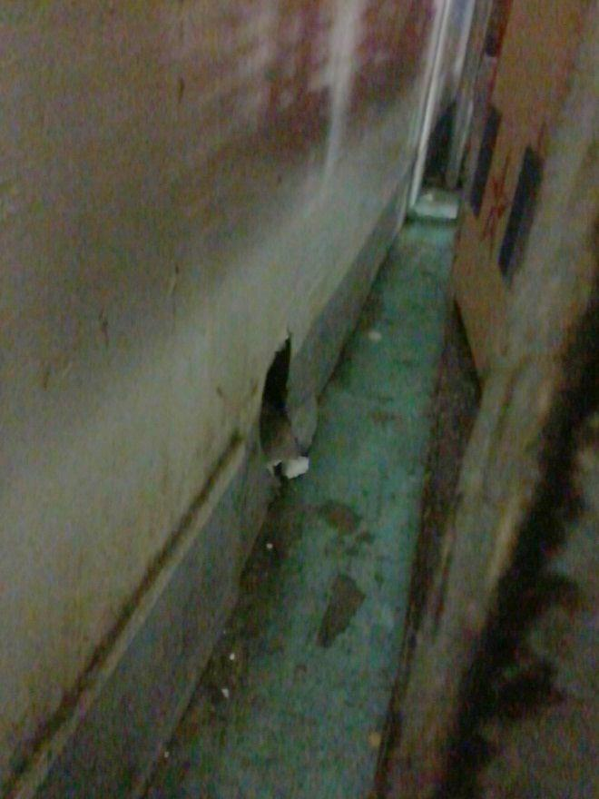 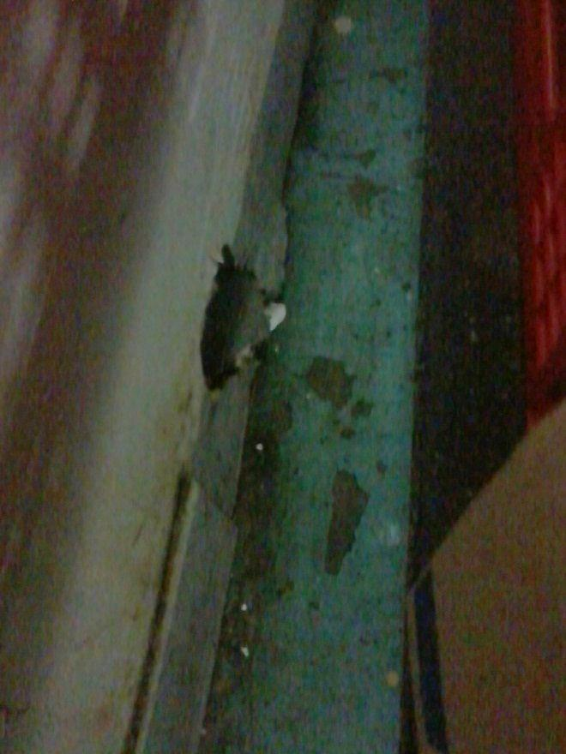

**2 HOLES IN BASE BOARD (WALL) AT BASEMENT TRANSPAC. EQUIP. AREA**